Palm Schwenkfelder Church
Associate Member: United Church of Christ

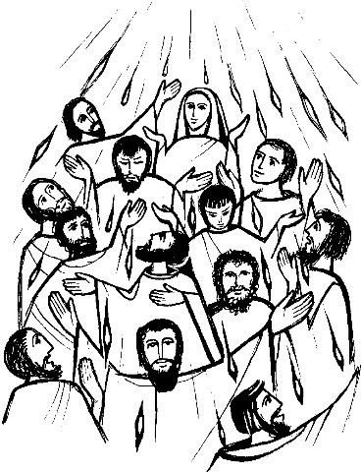

833 Gravel Pike

PO Box 66

Palm PA 18070

215-679-5321

PalmSchwenkfelder@verizon.net

Palm Schwenkfelder Church
Sunday, May 24, 2015
Pentecost
Confirmation
Communion
Memorial Sunday

Chimes

Welcome and Announcements

Prayer

Prelude “Come, Holy Ghost, Our Hearts Inspire”
Edward Broughton

*Call to Worship
We gather together because God has called us.
We wait in expectant awe for God’s appearing.
We are together, old and young, rich and poor.
We have come, believers and skeptics, to this place.
On the first Christian Pentecost, there were surprises:
the rush of a violent wind and tongues of fire.
We tremble before the power of the Holy Spirit.
What will happen if we let the Spirit in?
On this Pentecost, we can receive the surprises of God.
We can be moved to speak and act in new ways.
With hesitant eagerness, we welcome the Spirit.
We will risk stepping into God’s vision for us.

*Hymn #291 “Sweet, Sweet Spirit”

Call to Confession

Prayer of Confession
Lord, we acknowledge today that we like to be in control, and we are scared to let go of the familiar and understandable. We want to receive the gift of the Holy Spirit, but only on our own terms, without too much being demanded of us. We resist your guidance and the empowerment promised us in Jesus Christ. Forgive us, gracious God, and call us to once again be filled with the Holy Spirit. Amen.

Time of Personal Confession

Assurance of Pardon

Scripture Acts 2:1 – 21 (NRSV p. 885; LP p. 1703 – 1704)

Children’s Sermon

Children’s Church No Children’s Church Today

*Hymn #289 “Holy Spirit, Ever Dwelling”

Sermon “Filled with the Spirit”

RITE OF CONFIRMATION

Invitation

Sentences

Questions of the Candidates

Affirmation of Faith

Apostle’s Creed
I believe in God, the Father Almighty,
Creator of heaven and earth.
I believe in Jesus Christ, his only Son, our Lord,
He was conceived by the Holy Spirit,
born of the Virgin Mary.
He suffered under Pontius Pilate,
was crucified, died, and was buried.
He descended to the dead.
On the third day he rose again.
He ascended into heaven,
and is seated at the right hand of God the Father.
He will come again to judge the living and the dead.
I believe in the Holy Spirit,
the holy catholic church,
the communion of saints,
the forgiveness of sins,
the resurrection of the body,
and the life everlasting. Amen.

Act of Baptism

Prayer of Candidates
O God, my God, known to me in Jesus Christ, I give myself to you as your own, to love and serve you faithfully all the days of my life. Amen.

Prayer of Congregation

The Lord’s Prayer
Our Father, who art in heaven,
hallowed be thy name.
Thy kingdom come,
thy will be done on earth as it is in heaven.
Give us this day our daily bread,
and forgive us our debts,
as we forgive our debtors.
And lead us not into temptation but deliver us from evil:
For thine is the kingdom, and the power, and the glory,
forever. Amen.

Act of Confirmation

Prayer of Confirmation

Address

Question about Participation

Welcome
Let us, the members of Palm Schwenkfelder Church, express our welcome and affirm our mutual ministry in Christ.

People
We promise you our continuing friendship and prayers as we share the hopes and labors of the church of Jesus Christ. By the power of the Holy Spirit may we continue to grow together in God’s knowledge and love and be witnesses of our risen Savior.

Greeting of Christian Love

Prayer

Benediction

Signing of the Membership Book

Congratulations to the Confirmation Class of 2014 – 2015
Job Kinsler, Joseph Kinsler, Andy Kriebel, Blake Master,
Stacey May, Kaitlyn Mundy, Kate Pence, Andrea Simon

Call to Offering

Offertory “Come, Holy Spirit, Heavenly Dove” Wilbur Held

*Doxology
Praise God, from whom all blessings flow;
Praise Him, all creatures here below;
Praise Him above, ye Heavenly Host;
Praise Father, Son and Holy Ghost. Amen

*Prayer of Dedication
God of wind and fire, may new life be breathed into the world because of these gifts we return to you. Grant us enhanced capacity to carry your revelation to others in ways they can understand. We seek to be to one another channels of your love and peace, both in person and through the outreach of our offerings. Amen.
The Sacrament of Holy Communion

Senior Choir Anthem “Communion Kum Ba Yah” Traditional Spirituals
arr. Bret Rhoads and Steve Kupferschmid

The Invitation
Jesus said: I am the bread of life. You who come to me shall not hunger: you who believe in me shall never thirst.
In company with all who hunger for spiritual food, we come to this table to know the risen Christ in the sharing of this life-giving bread.

Communion Prayer and Consecration

Breaking Bread and Pouring Wine

Sharing the Elements

The Prayer of Thanksgiving (Unison)
Eternal God, you have called your people, young and old, to feast at the table of Jesus Christ. Unite us with all who are fed by Christ’s body and blood that we, like those on the first Pentecost, may faithfully proclaim the good news of your love and that your universal church may be a rainbow of hope in an uncertain world, through Jesus Christ our Redeemer. Amen.

*Hymn #568 “Take My Life and Let It Be Consecrated”

Congregation, Please Proceed to the Cemetery

SERVICE OF REMEMBRANCE

Introduction

Reading of the Names:
Bernard Beard Anna Bieler Sue Carlin
Jack Covington Pam Gibbons Robert Hartman
John J. Kirwin Charles Krauss Blanche Schultz
Clark Schultz Leslie Stull Fern Wolf

Memorial Prayer

Hymn #708 “Blessed Be the Tie That Binds”

*Benediction

Postlude “Come, Holy Ghost” by James Konkel

Carillon

*All who are able, please stand.

Today’s altar flowers and bulletins are presented in loving memory of Horace Hoffman by Mr. and Mrs. Richard Hoffman.

Communion Note
The Lord’s Table is open to all who confess Jesus as the Christ and seek to follow Christ’s way. The Deacons will serve the congregation in the pews. Trays should be passed halfway through the pew and then returned to the same deacon, take the bread or grape juice while the person next to you holds the tray. Please hold the bread and the cup until the Pastor invites everyone to eat or drink. Then quietly place the cup in the holder on the back of the pew.
Note: Gluten-free Communion Wafers (individually wrapped) are provided on the bread trays for people with wheat sensitivity.

“Concerning the Communion Service of Palm Schwenkfelder Church, children of our congregation take communion after confirmation. If you choose to have your children partake in Communion please explain the sacred meanings behind the ritual. If you would like to speak with someone on the meanings of Communion please speak with Pastor Nick or any Deacon.”
Deacons of Palm Schwenkfelder Church

Mission Statement of Palm Schwenkfelder Church:
Our task is to proclaim the Living Word of God, which empowers us to care for and share with our community and the world.

Vision Statement of Palm Schwenkfelder Church:
Serving the glorious God, claimed by Jesus, and inspired by scripture, honoring our history, with renewed commitment we will reach out to our community and the world through worship, spirit enriching programs, and outreaching mission.

Thank you to Reverend Barbara Pence for participating in today’s service.

…Things of Interest to Our Palm Schwenkfelder Family…

This week, please keep in your daily prayers:
The family of Anna Bieler, Verna Badman, Donald Long, Brian Shelly, Bob and Lucile Jones, Jean Gentry, Bob Croll, Glenn Hoffman, Mary Hartman, Erin Beighley, Bob Frey, Sandy Zuchero, Janet Esposito, Alice Davis, Mary and Heinz Herrmann, Rick Jones, Bryan Schwoyer, Clara Graber, Earl Yerger, Jen Fries, Doris Masemore, Wanda Gentry, Margaret Wallinger, Reverend Ed Winslow, Ernie Guldin, Vern Weller, Betty Serff, Mary Jane Burianek, Karen Freed, Donald Cook, Dave Jaeger, Robert Margerum, Helen Miller, Rob Ziegler, John Hathaway, Betty Pope. Please also keep in your prayers the men and women serving in the United States Military. This month from our Schwenkfelder Prayer list we uplift The Board of Music Ministries.

Bible Study
King Saul's other daughter, Michal in 1 Samuel 18, and his son, Jonathan in 1 Samuel 19, complete a construct begun with Merab. That will be the focus for this week's online Bible Study. Help us discern that lesson by contacting Rick Jones or the Church Office with an email address.

May Kindness Look-Out
Music Ministry and Choir , Please help us catch those kids being kind! Punch cards are located in the Narthex. You may punch the fish card yourself or you may ask the youth to punch the fish card. Thank you for helping! “Follow me, and I will make you fishers of men” Matthew 4:19

May Palm Youth Birthdays
Happy Birthday to…
Andrea Simon (5/6), Emily Badman (5/7), Selia Werth (5/10)

Bible App for Kids
Current new stories: Waters Part and Walls Fall (Entering the Promised Land),
A Hairy Tale (Samson), A Voice in the Night (Samuel is called to God), Stones Slings and Giant Things (David and Goliath). This is a great app for kids of all ages. Download it for a fun interactive way to read about God’s holy word.

You Version Holy Bible App
This is a wonderful app for daily Bible reading. You can choose plans that focus on family, devotionals, youth, religious times of the year, reading partial Bible segments at a time, or a plan that helps you read the whole Bible so it doesn’t feel cumbersome. It also includes some plans with music and some plans with videos. It keeps you on track and gives you many choices so you can choose what’s right for you. Current New Plans: Pray, God Is…, Finding Hope at Home, Fearless, Chosen, Ambition and Your Work, and
Deeper Into Scripture: 2 Thessalonians

Confirmation Class
Next Sunday, May 31st, at 1:00pm the Confirmation class will be touring Animals in Distress located in Coopersburg. Bring a lunch or meet back at the church at 12:30.

Camp Discovery ~Vacation Bible School
We love because He first loved us. 1 John 4:19
Journey down the trails of Camp Discovery and step out in faith! Explore Bible truths that point to Jesus, our True North. Kids discover that God has a plan and a purpose for us. He calls us to serve our neighbors. Join us on Sunday, June 21st thru Thursday, June 25th 6:15-8:30pm. Registration is on Sunday, June 21st at 6pm or you may pre-register by filling out a form and handing it in to the church office. Our program is for ages 4 years through 5th grade. Older youth volunteers are needed and very welcomed to help.

Sunday School Calendar
Sunday, May 24th – Class Presentations by the Confirmands
Sunday, May 31st – Last teaching day for Sunday school teachers
Saturday, June 6th – Youth Sunday rehearsal at church, 2:00pm
Sunday, June 7th – Youth Sunday during worship with a rehearsal at 9:00am
Sunday, June 14th – Combined Sunday school – closing program

Summer Music
Spring is in the air, and summer will be here soon. This means our regular choirs get a break. Summer special music for Sunday worship services is being scheduled. If you know of anyone who would be willing to share their musical talent, please speak to any one on the music committee, or sign up on the sheet posted outside the office.

Spread The Word About Palm
Are you on Facebook? Did you know the church has our own Facebook page? Please consider “LIKING” our Facebook page to see the weekly happenings at church – and enjoy occasional inspirational messages. If you already follow the church’s Facebook page – please consider asking your fellow “Facebook Friends” to like our page, so they too can see our upcoming events and enjoy our church’s activities. Thank you.

Relay For Life
Our 2015 Relay for Life Team members extend their deepest appreciation to the congregation and friends of the church who contributed throughout the year to our fundraising projects. Many lives were touched by your generous gifts to the American Cancer Society. THANK YOU!

We also gratefully acknowledge the following for their contributions of prizes and donations for our “Gift Card Super Raffle:” Lil & Walt Master, Ed & Kathy Bieler, ABE Maintenance, Kevin & Barb Master, Dave & Carol Woodward, Tom & Tammy Long, The Palm Ladies’ Aid Society, Doug Wallinger & Diane Koenig, Blake & Brent Master, Friends of the Relay Team, Lee Schultz, Brian & Renee Shelly, Frank & Ethel Soffa (In Memory of Jim Kresge), The Badman Family, Lawrence Croll, Harry & Diane Irvin, Jeff & Bonnie Treichler. Thank you, everyone!

A big “Thank You” to the youth of our church, who designed and created a “Waving Goodbye to Cancer” banner for the day of the Relay event. Palm’s team walked proudly behind the banner during our team parade.

Make Music Upper Perk
Make Music Upper Perk is a community festival held annually on June 21st – invites the congregations of the Valley to join for a special day of fellowship and musical performances. This year several churches will be host for the festivities – the Gazebo at St. Mark’s Lutheran and the Porch at Pennsburg UCC’s – in addition to other venues around the Valley. All performances are free to the public and will feature local musicians, bands, and choirs. The day will be a celebration of music in our local community and will include genres for all ages. The full schedule will be released in the Town & Country in June as well as at the ValleyArtsScene.wordpress.com .

Altar Flower and Bulletin Sponsorships
There are several upcoming dates open for sponsorship of our Sunday flowers and bulletins. Dates available for flower sponsorship on:
August 2nd, September 6th, October 4th and 11th
We have openings for bulletin sponsorships on:
June 14th and 21st; August 9th and 16th, September 6th, October 11th
The cost for flower sponsorship is $50, and the cost for bulletin sponsorship is $15.00. Please sign up on the chart in the hallway outside of the office. And, thanks!

Address Changes/Updates
As a service to our members, any address changes that come through the office will now be listed in the bulletin. There will also be a section in the Palm Leaves that will list new addresses. If you have any information on members who have may have moved, or if any of the addresses listed appear to be incorrect, please
call the office to let us know. Thank You.

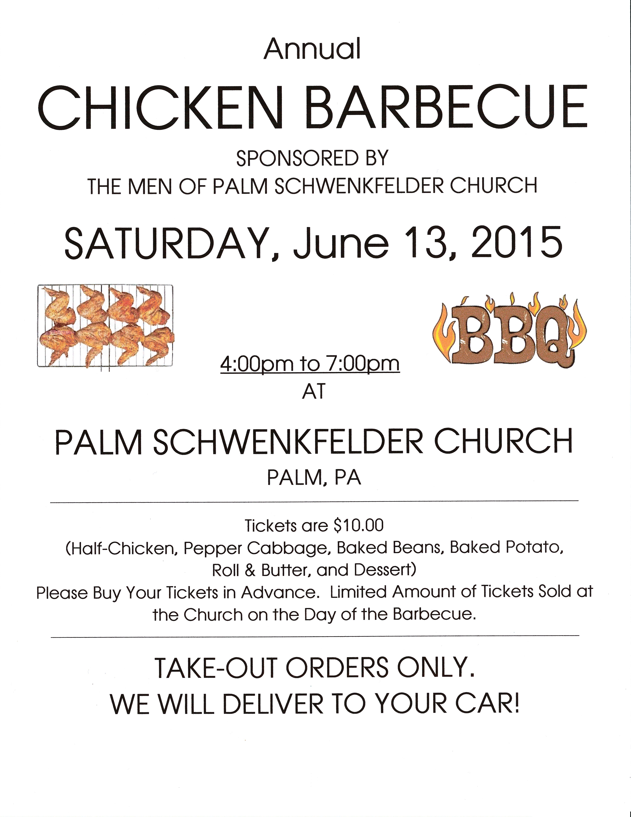

This Week at Palm Schwenkfelder Church

Sunday, May 24
9:00am Sunday School
10:15am Pentecost/Confirmation/Communion/Memorial Day
Sunday Church Service
12:00pm Daily Time of Prayer Wherever You Are

Monday, May 25
Memorial Day
12:00pm Daily Time of Prayer Wherever You Are

Tuesday, May 26
Office Closed
8:00am Quilters
12:00pm Daily Time of Prayer Wherever You Are
7:00pm Boy Scouts
7:00pm Girl Scouts Senior/Ambassador Troop

Wednesday, May 27
Office Closed
12:00pm Daily Time of Prayer Wherever You Are
7:00pm Boy Scouts Board of Review

Thursday, May 28
12:00pm Daily Time of Prayer Wherever You Are

Friday, May 29
12:00pm Daily Time of Prayer Wherever You Are

Saturday, May 30
12:00pm Daily Time of Prayer Wherever You Are

Sunday, May 31
9:00am Last Teaching Day of Sunday School Classes
10:15am Sunday Worship Service
12:00pm Daily Time of Prayer Wherever You Are
12:30pm Confirmands Leaving For Visit To Animals in Distress
Palm Schwenkfelder Church
833 Gravel Pike
PO Box 66
Palm PA 18070
Office Phone: 215 – 679 – 5321
Fax: 215 – 679 – 2650
Pastor Nick’s Cell Phone: 267 – 374 – 5691

Sunday School 9:00 a.m. Worship Service 10:15 a.m.

Church Office Hours (Week of 5/25/2015)
Closed Monday – Wednesday
Thursday 8:00am – 4:00pm
Friday 8:00am – 3:00pm

www.palmschwenkfelderchurch.com

Church Administrator E-mail: palmadministrator@comcast.net

Church Office Email: palmschwenkfelder@comcast.net

Pastor’s E-mail: palmpastor@comcast.net

Copyright License Number: 1433223

- Serving You at Palm Schwenkfelder Church
Ministers: All Church Members
Pastor: Rev. Nicholas Pence
Pastor Emeritus: Ronald R. Krick
Director of Music: Ed Bieler
Children’s Choir: Gail Ferry
Children’s Choir Accompanist: Joan Pusey
Junior Bells: Beth Croll
Senior Bells: Joanne and David Luz
Organist: Peg Jacob
Church Administrator: J. Daniel Ferry
Youth Director: Barbara Master
Sexton: Kevin Master 484 – 358 – 1684
Greeter: Gail Brown
Ushers: Nancy Hoffman, Tim Hoffman, Richard Kleppinger, Lisa Stitt Prayer Chain: Nancy Hoffman 610 – 845 – 7208

The Call to Worship and Prayer of Dedicati0n are both reprinted by permission of Geneva Press from When We Gather by James G. Kirk. Copyright 2001 by Geneva Press.

